

4.11: Nested If Statements

However, this result is not quite right yet – if we enter the number 6, it should say that it is both even and divisible by 3.

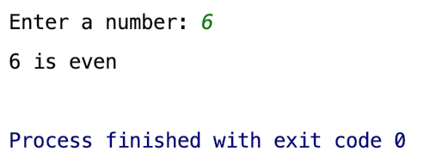

This is not the case at the moment. This is because the if statements are evaluated in the order they have been written in. As soon as the program reaches one which gives a true result, it completes the required code block, then skips straight to the next line after the else statement is completed:

Therefore, let’s consider the possible options we have:

* Even and divisible by 3
* Even and not divisible by 3
* Odd and divisible by 3
* Odd and not divisible by 3

Currently, our system caters for the following options:

* Even
* Odd and divisible by 3
* Odd and not divisible by 3

So, we need to split the even option into two further outcomes – divisible by 3 and not divisible by three. To achieve this, we are going to nest another if statement within our first if.

Adapt your program so that the if statement now reads:

if (number % 2 == 0):

if (number % 3 == 0):

print(str(number) + " is even and divisible by 3")

else:

print(str(number) + " is even and not divisible by 3")

elif (number % 3 == 0):

print(str(number) + " is odd and divisible by 3")

else:

print(str(number) + " is odd and not divisible by 3")

You will notice that we now have an if statement contained within the first if statement (so we have nested the statements.

Now you, should be able to test the function (with no changes to main!) to ensure that it functions as expected. You will need to do 4 tests:

1. A number which is even and divisible by 3 (let’s use 6)
2. A number which is odd and divisible by 3 (let’s use 9)
3. A number which is even and not divisible by 3 (let’s use 4)
4. A number which is odd and not divisible by 3 (let’s use 5)



You will notice from this that we have selected numbers which will make sure that each condition is executed correctly. We don’t need to test more than once for each condition – if it works for one number, it should work for them all.

**Your Turn 4:**

Using a nested if statement, adapt your program so that if Wednesday is entered, the following is output AFTER it says that it isn’t payday:

“Halfway through the work week – keep it up!”

